

L 7, 1 • 68161 Mannheim
Postanschrift/Mailing address:
Postfach 103443
D-68034 Mannheim
Tel.: 0621/1235-01 (Zentrale)
Internet: http://www.zew.de/

University of Southhampton  Department of Economics  Dr. Christos Kotsogiannis  Hightfield  GB-Southampton SO17 1BJ | Ansprechpartner:  Robert Schwager  Telefon:  1235-160  E-mail:  schwager@zew.de  Telefax:  1235-215  Datum:  28.07.2026

Dear Mr.Kotsogiannis,

thank you for confirming your participation in the 2nd ZEW summer workshop to take place from June,19th-21th. There are some organizational details which we would like to communicate to you. For convenience, we decided to use e-mail instead of paper mail.

(1) Travel assistance: ZEW will provide up to Euro 400.- in order to cover part of your travel expenses (please keep your receipts for reimbursement).

(2) Hotel accommodation: We have booked a room for at
Delta Park Hotel
Keplerstrasse 24
D-68165 Mannheim
phone: ++49 0621 44 51 0
fax: ++49 0621 4451888
e-mail info@delta-park.bestwestern.de
If you haven't yet indicated the dates of your stay please do so as soon as possible.

(3) How to get to Mannheim and ZEW: If you arrive at Frankfurt airport (the international airport closest to Mannheim), go to the station for long distance trains ("Fernbahnhof") where a direct train to Mannheim leaves at least every hour and usually takes 31 minutes (The price is DM 34 for a single trip). From Mannheim central station to Delta Park Hotel it is a 10 minutes walk. Find attached the map with the location of the hotel. Find below the location of ZEW (approximate walking time between Delta Park Hotel and ZEW: 15 min.).

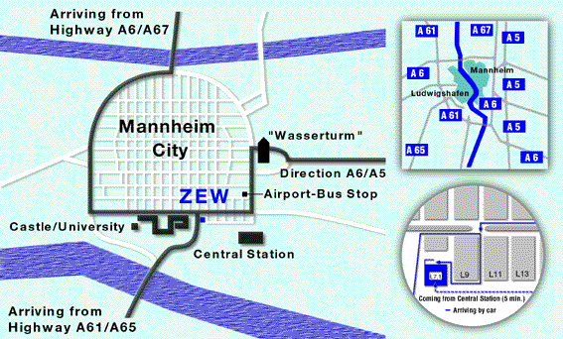

(5) Workshop program: You will receive a detailed program via e-mail shortly.

(6) Last but not least - your paper: If you haven't already sent a complete version of your paper please do so, if possible, because we want to distribute your work to the lecturers in advance. We would like to obtain all papers in electronic form to speed up things.

We are looking forward to meeting you in Mannheim.

With best regards,

Christoph Böhringer and Robert Schwager

